ECE 594Q

Special Topics in Image Synthesis

Final Report



UCSB

ECE

Bingrui Dong

9383738

2016.3.18

**Path Tracing with Motion Blur and Thin Fog in Cornell Box**

1. Introduction

For the final project, the aim is to use the Path Trace to render the simple object in Cornell Box with Motion blur and the thin fog effect. The Cornell Box scene file is inputted by the ASCII file. Based on the basic path trace method, a simple adaptive filter is used to accelerate the rendering speed. In addition, the Bidirectional Path trace is used to increase the quality of the image and the speed of the rendering.

1. Basic Cornell Box Scene

The basic Cornell Box scene is consisted of two transparent balls and a cubic box with red and green wall on the right and left sides. Shown in Figure 1, the image is render by basic path trace.

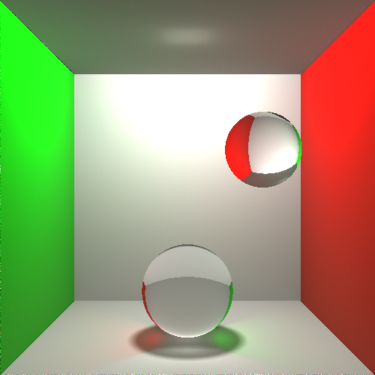

Figure 1. Basic Cornell Box scene with Path Tracing (600 * 600, 2048SPP)

1. Improve By Bidirectional Path Trace and the Adaptive Sampling

The paper BIDIRECTIONAL PATH TRACING by Eric P. Lafortune and Yves D. Willems demonstrated a great way to improve the quality of the path trace, especially when the light source is shelter by objects.

Shown in figure 2. The light source also fire light ray and the ray also bounds when hit objects. And each time the ray from the eye hits any object, the intersection point will shoot shadow rays to each point that the light source has intersected with.

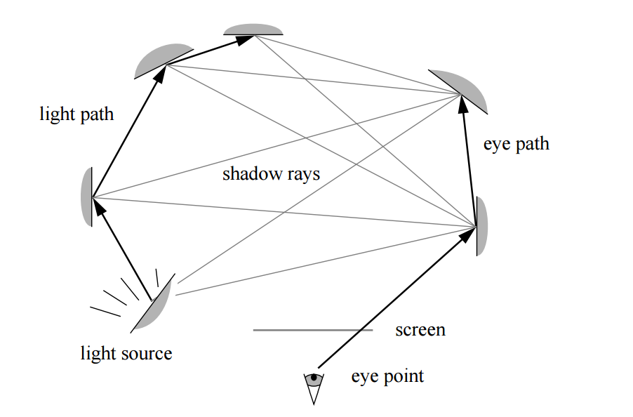

Figure 2. The idea of the bidirectional path trace. (Image source from BIDIRECTIONAL PATH TRACING by Eric P. Lafortune and Yves D. Willems)The Figure 3. shows the the result of the Path tracing and the Bidirectional Path trace methods.

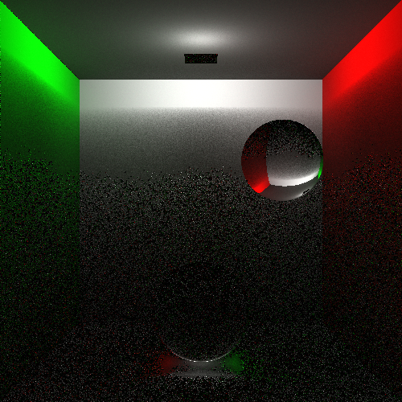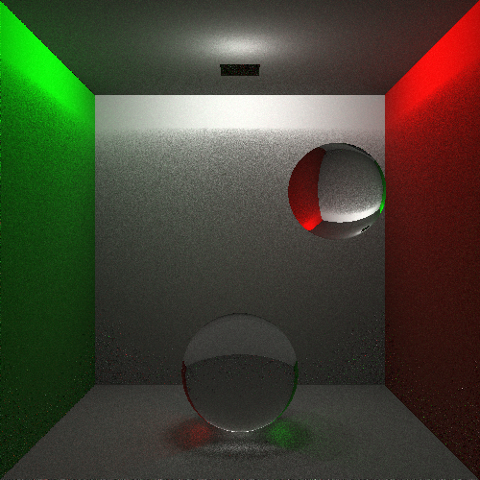

Figure3. Path Trace (600 * 600,256SPP) Bidirectional Path Trace(600 * 600, 64SPP)

without Bidirectional Path Trace(left side) and the Bidirectional Path trace result (right side). All the image take the same time to render. The Bidirectional Path Trace method gets the better result.

1. Motion Blur

By Monte Carlo integration, Motion Blur is achieved by add a random position shift before the detection of the intersection. Define the exposure time and moving speed of the object, give a random time point, and the according shift position before the path trace intersection detection. Shown in Figure 4.

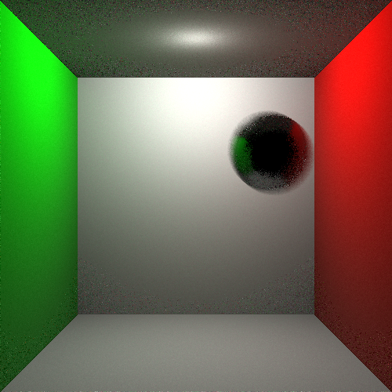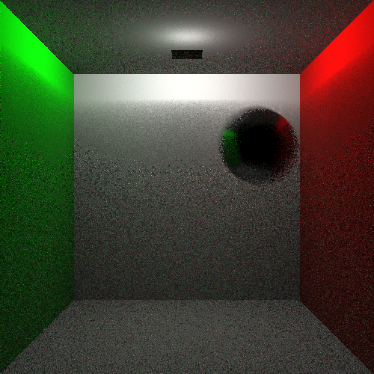

Figure 4. The left image is rendered with motion blur by Bidirectional Path trace, but without and filter in front of the light source. The right side image is rendered with Bidirectional Path Trace, with a square in front of the light source.

1. Single Scattering Integrator and Thin Fog effect

The Light Scattering Integrator is achieved by adding the value of the Ray Marching. Any ray in the scene will be sampled to points in the scene, and each point will shoot a shadow ray to the light source. And the absorbtion is a continues effect, and its integration is just an exponential function, and the parameter is settled to the Fog.

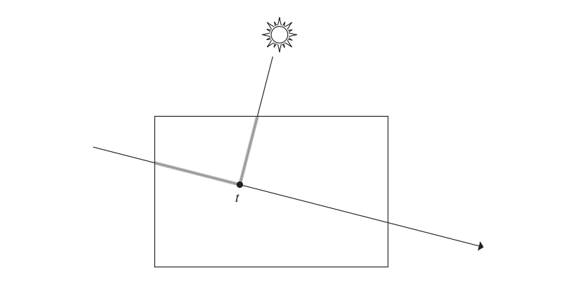

Figure 5. The Scattering Integrator. (Image Source from PBRT)

1. Final Demonstration

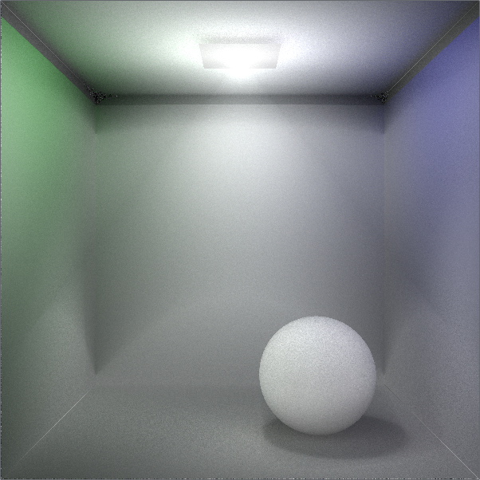

Figure 6. Scene with spot light, with Thin Fog, without Motion Blur. (600 * 600, 128 SPP, 0.06 Ray Marching Distance)

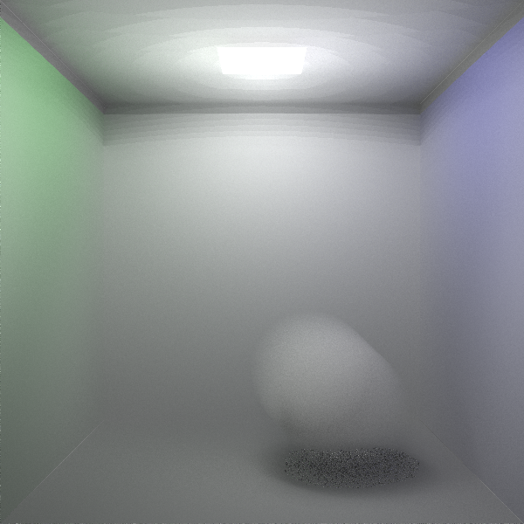

Figure 7. Scene without spot light, Thin Fog effect with Motion Blur (600 * 600, 128 SPP, 0.066 ray march distance)

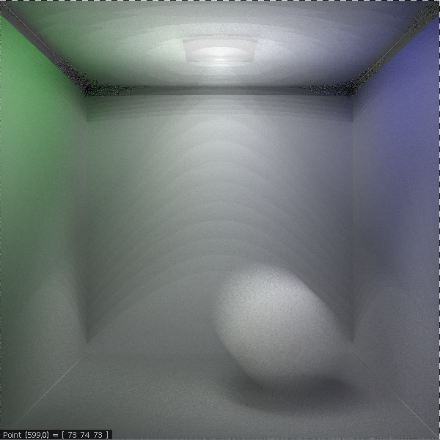

Figure 8. Thin Fog effect with Motion Blur (600 * 600, 128 SPP, 0.5 ray march distance)